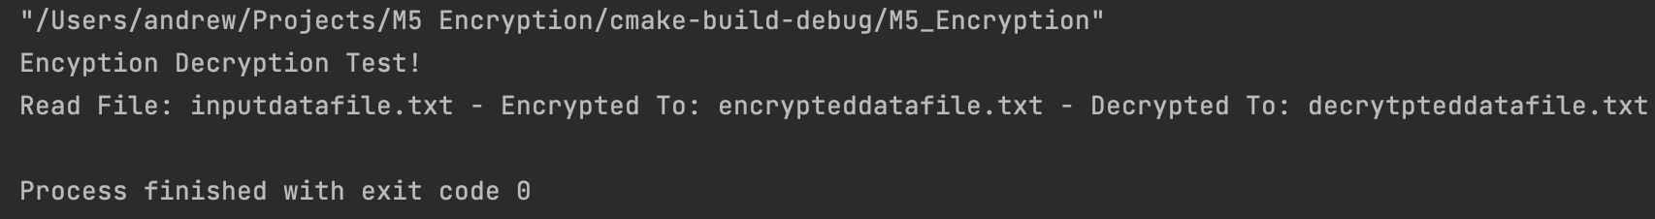

The process I took to complete this activity was the same as the other assignments; go one-by-one completing the sections marked with a TODO comment. Implementing the XOR encryption was as easy as inserting the variables in the template of key[i % keyLen]. Although I designed this on macOS, it should work on any platform given my use of the standard library with cross-platform methods.